AMCofWyoming.com (307) 682-3800
Trap Neuter Return
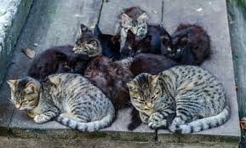

The Trap Neuter Return program at Community Veterinary Clinic can help you.
Do you have a feral (wild) cat population where you live? Do you put up with roaming, yowling, spraying, and fighting of cats? Are you worried about their health and wonder if it is even safe for you or your children to be around them?
What is Trap Neuter Return? Trapping wild cats and altering them quickly helps stabilize the regional cat population. It ends the cycle of reproduction by creating a healthy colony of cats. It also provides vaccination protection against Rabies which is a fatal disease for them as well as you. When altered, cats become better neighbors.
Why should you TRN instead of Catch & Kill or Relocate? TNR is proven to stabilize, if not end the reproduction cycle, whereas the other two methods have not been proven effective. Both Catch & Kill and Relocation don’t generally work because of what’s known as the vacuum effect: wherever there is a lack of cats, new cats will come in, breed to capacity and fill the ‘vacuum’.
How can CVC Help?
At CVC you can capture cats (for live trap info see side 2) and bring them in without prior notice. We are available 5 days a week and accept surgical patients each day. And we have become experts at handling feral cats – we get the cats altered, vaccinated, and returned to you the same day for a discounted price.
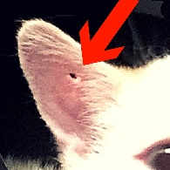
Last but not least, at CVC we will punch a hole in the top-mid portion of the ear so that at a quick glance it can be determined if a cat is altered and vaccinated. This allows you to get your cat population altered over a period of time and to know that all the cats are included.
For pricing information go to the Community Clinic page on our website AMCofWyoming.com or call us at (307) 682-3800. We would love to help you
with your wild cats.

Information about where to obtain live traps:
- Live traps can be borrowed for free from Campbell County Animal Control.
950 West Warlow Drive/(307) 686-5249
- Live traps can also be rented for a nominal fee at Campbell County Weed and Pest.
11 Northern Drive (307) 682-4369

Information on how to trap wild cats:
- Set a Feeding Schedule
Feed or start feeding the wild cats around your home in the same place and ideally at the same time every day. Do this for 1-2 weeks. Prior to setting the traps do not feed for 24 hours.
- Set the Traps
Prepare the traps away from the feeding site by lining the bottoms with newspaper and placing the bait/food in the very back of the cage. Place the trap on level ground, set them and wait. Once the trap is sprung it is best to cover it with a large towel and transport the cat to the veterinarian immediately.
- After Surgery Care
Keep the cats in the trap in a safe, dry, warm place for one night after the surgery. Provide water (and food if you would like to) when the cats are awake. Make sure to place the water in the cage very carefully – generally, the best way to do this is put the water in a very shallow dish and slide it into the trap by slowly lifting the back door of the trap just enough to slide it through. Returning the cats to the exact place that each one was trapped is the ideal return method.
For more detailed information on implementing the Trap, Neuter, Return process go to www.alleycat.org/Trap-Neuter-Return.

